**Name - Parmeshwar\***

**Assignment ( MAVEN & JenKINS)**

**Problem Statement: Automated Deployment of 3-Tier Web application**

Q2) Design and develop tasks required to build CICD pipeline using learned technologies to deploy 2-Tier **application** on cloud platform as a set of microservices on containerized platform such as docker. Deploy a web application on Docker container using MAVEN as build tool to install, test, package application which is fetched from GitHub Repository & deploy through Web Application as TOMCAT. Provision Infrastructure on AWS.

**Step 1) Created The Two instances in AWS**

**i) Master Instance with elastic ip**

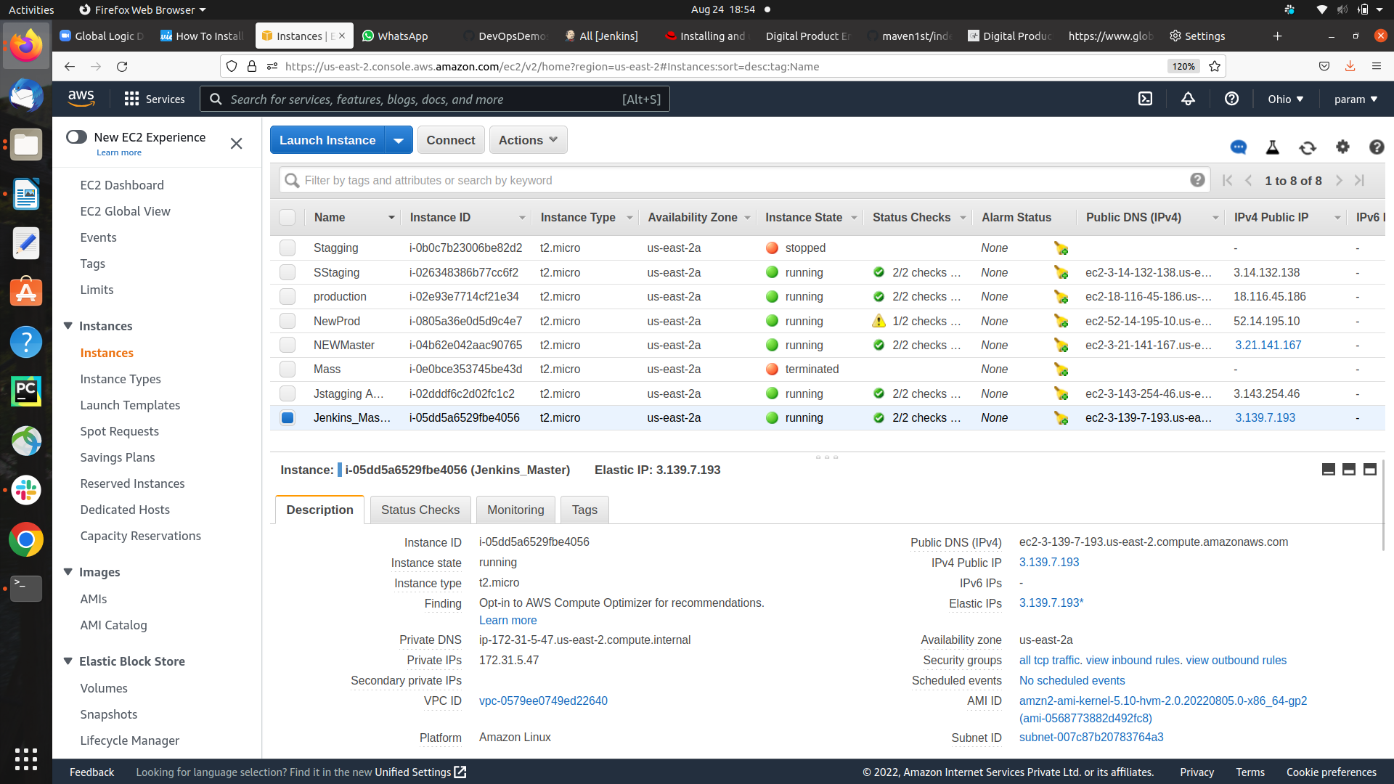

**ii) Stagging Intances**

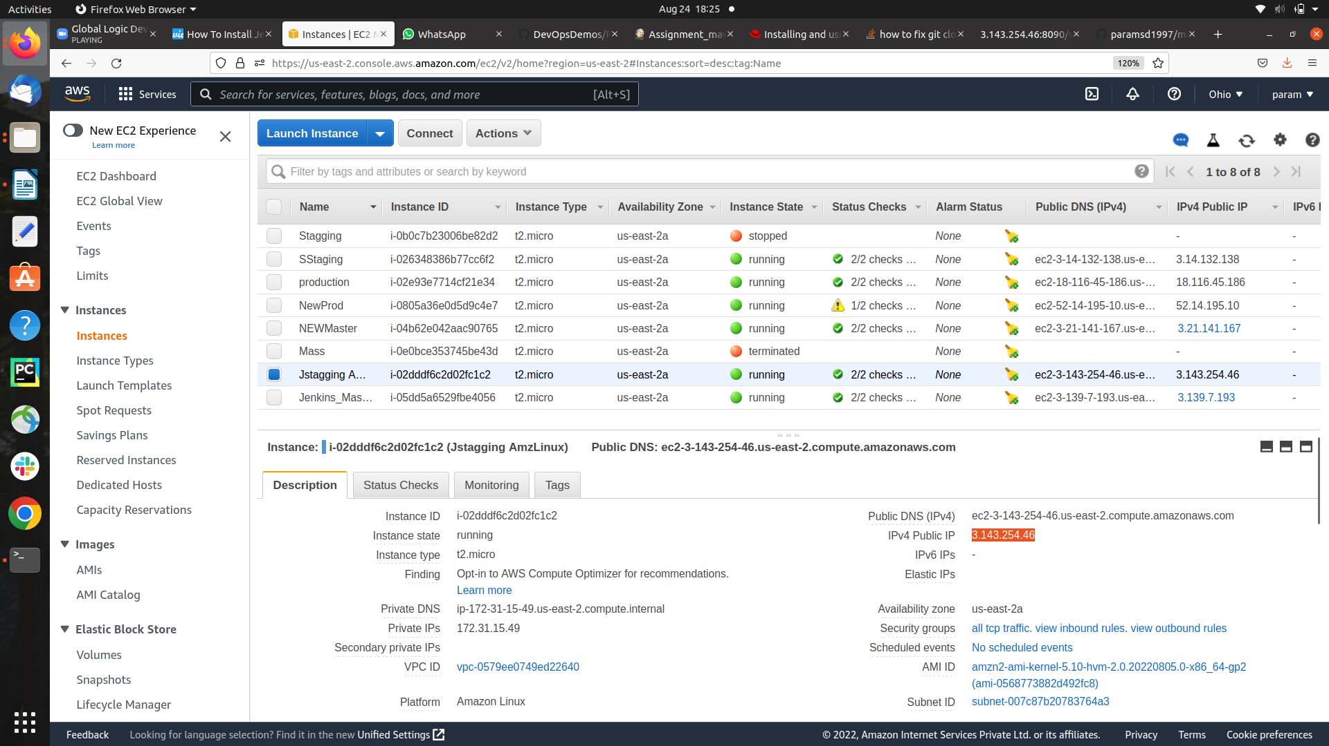

Step 2) Create a created job **Assignment_maven_project**

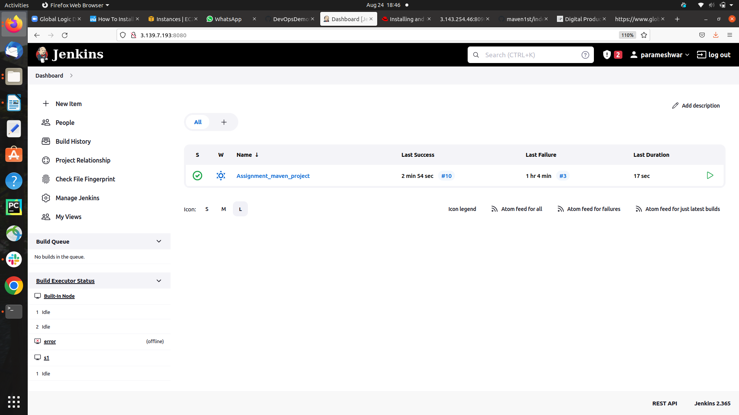

**step 2) Configuring the Project**

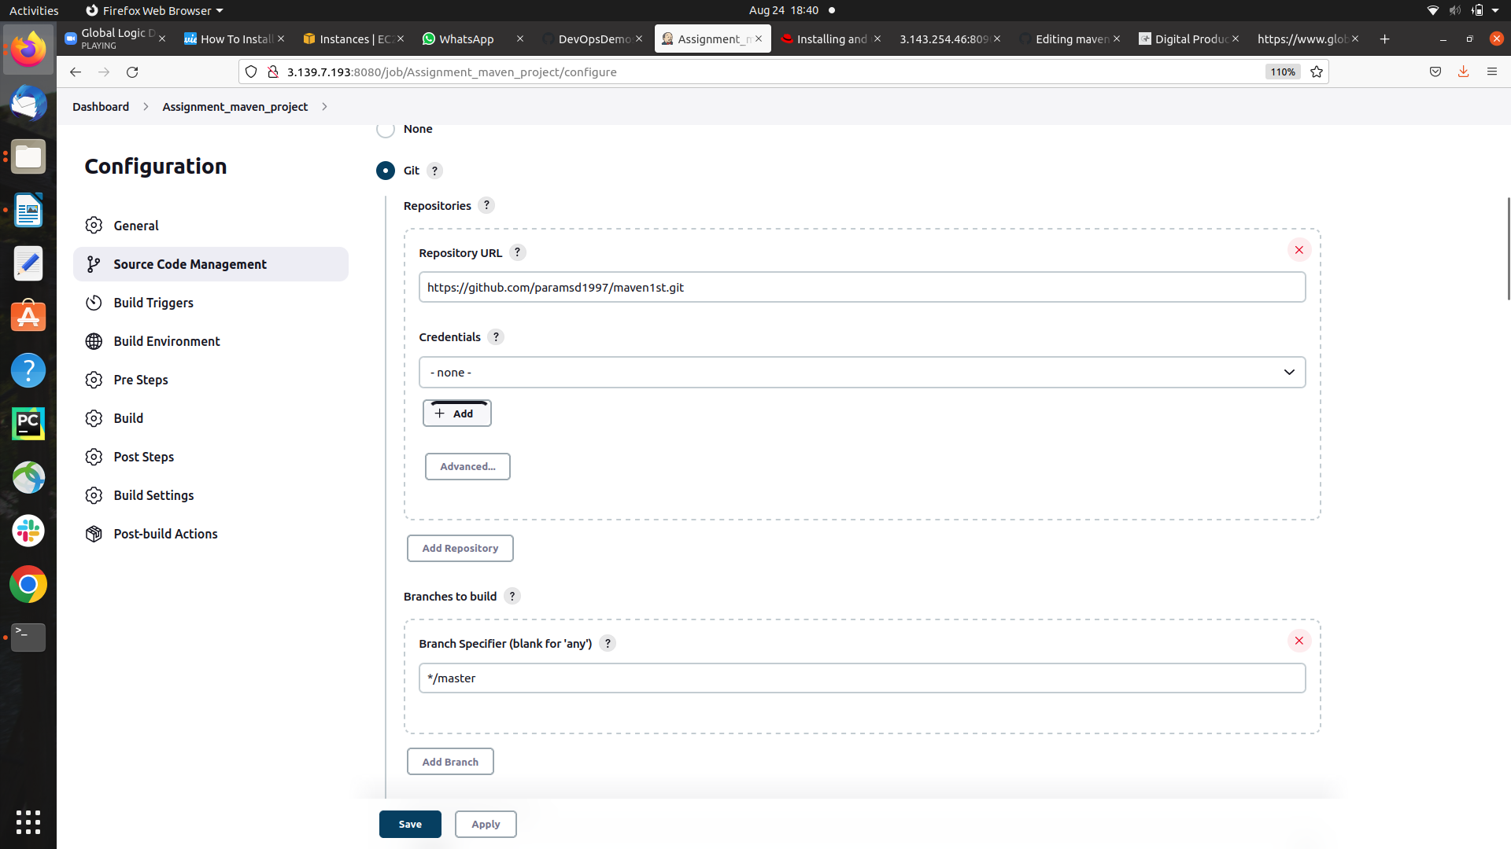

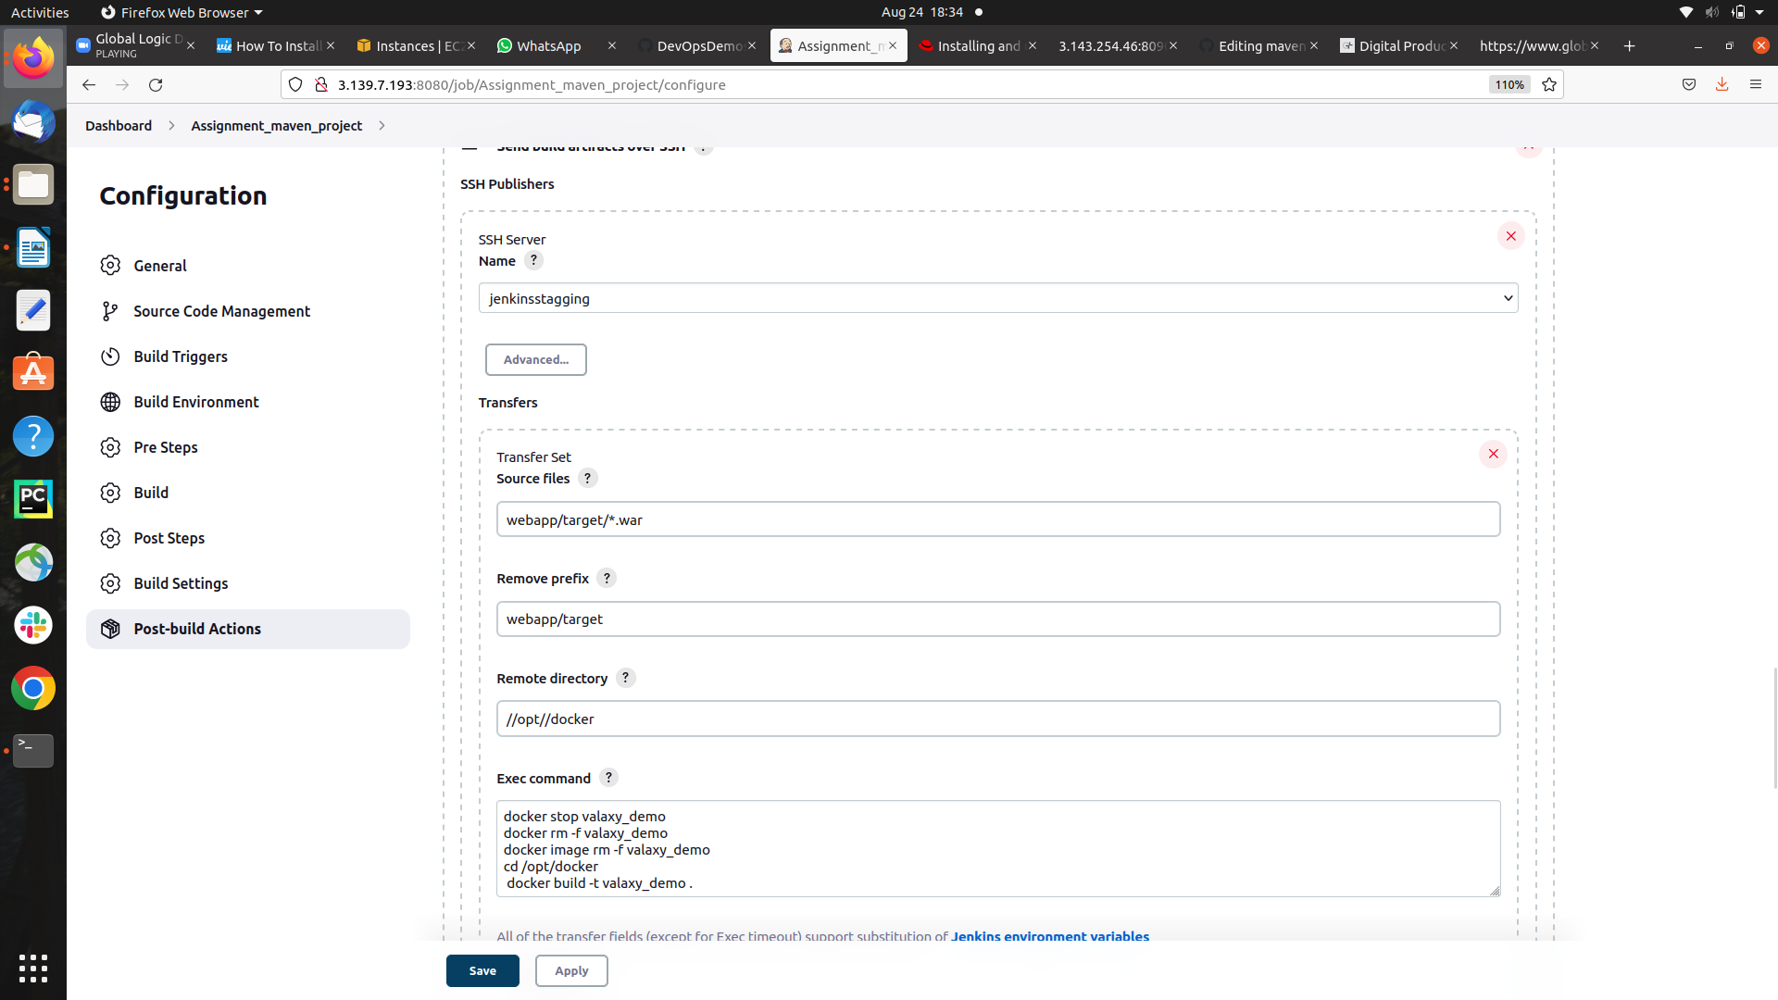

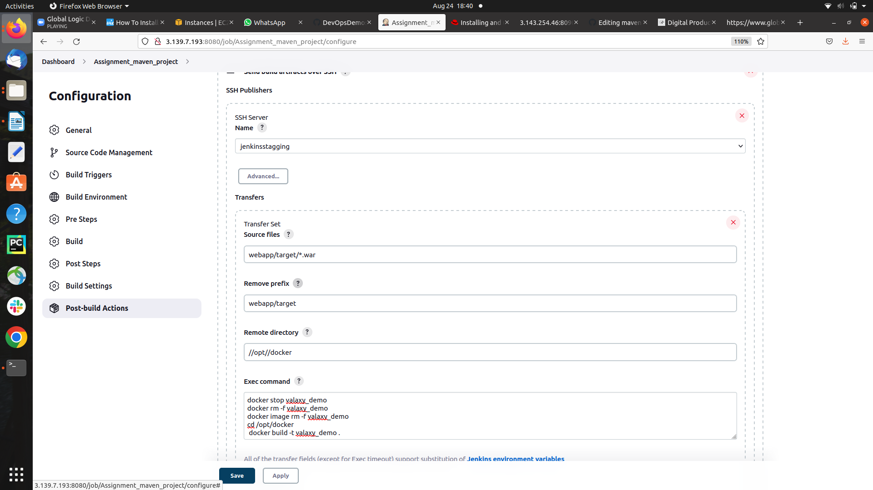

**Executing the cmd to Build and run the Container with assigned port**

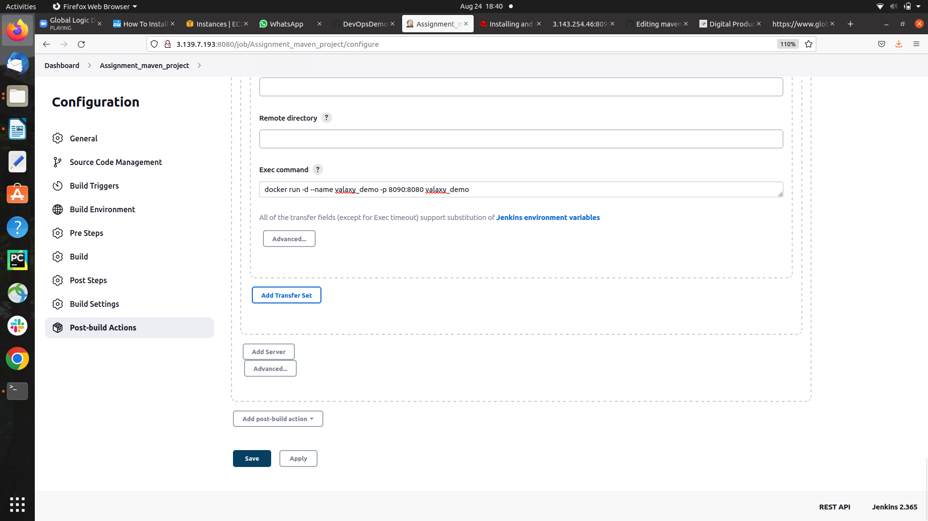

**step3 ) git repository Content**

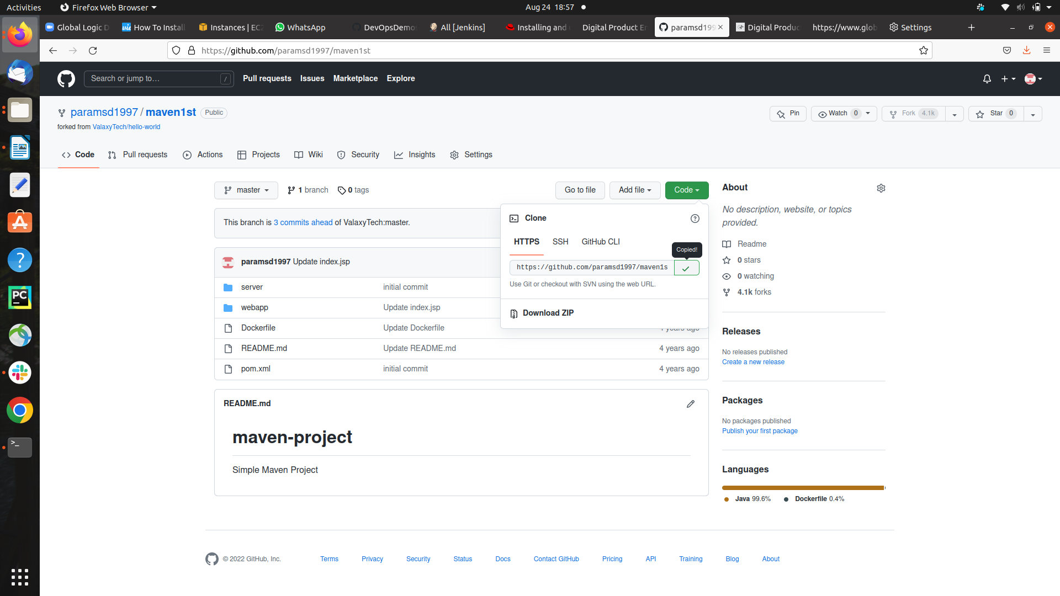

**step 4) Build the project output**

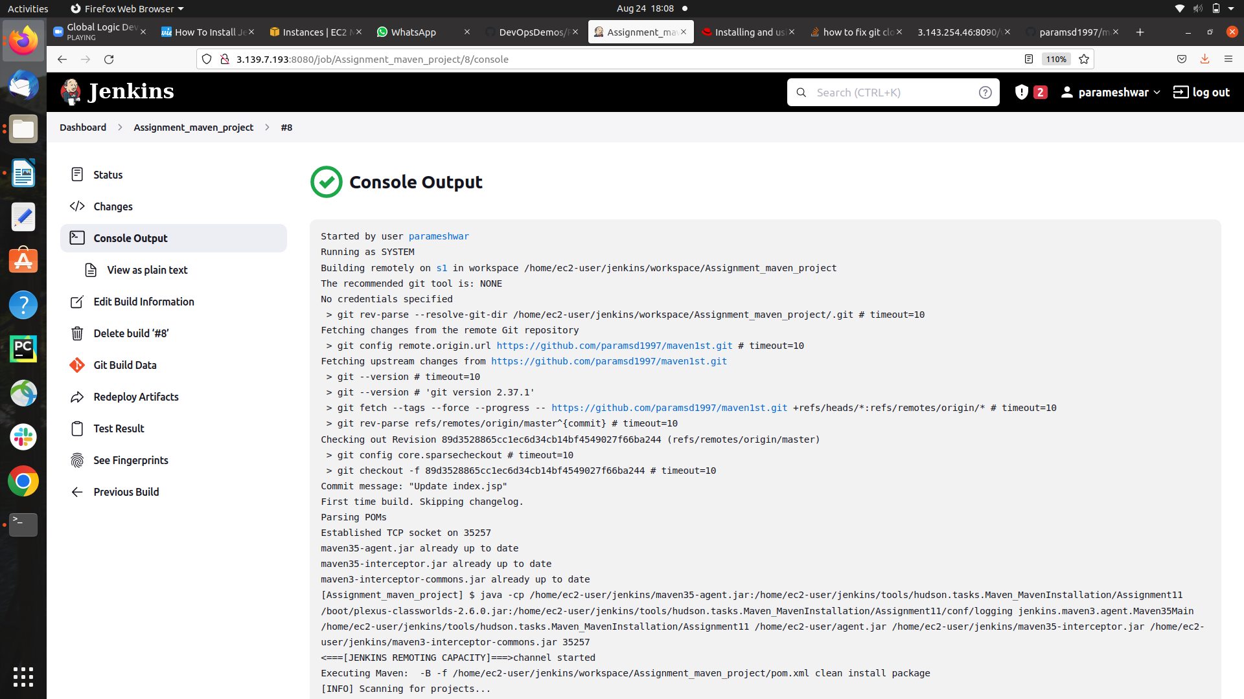

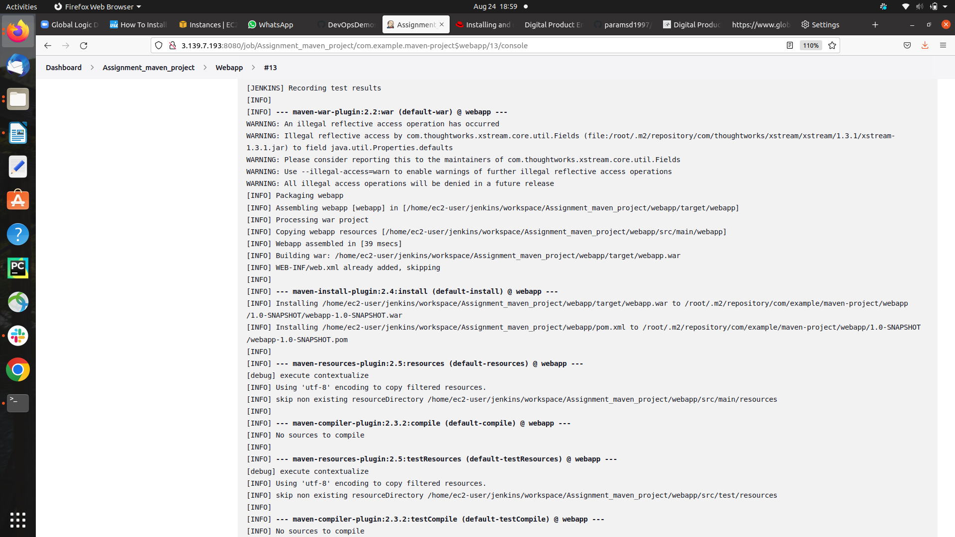

**Building the .war file**

**project Build Successfully**

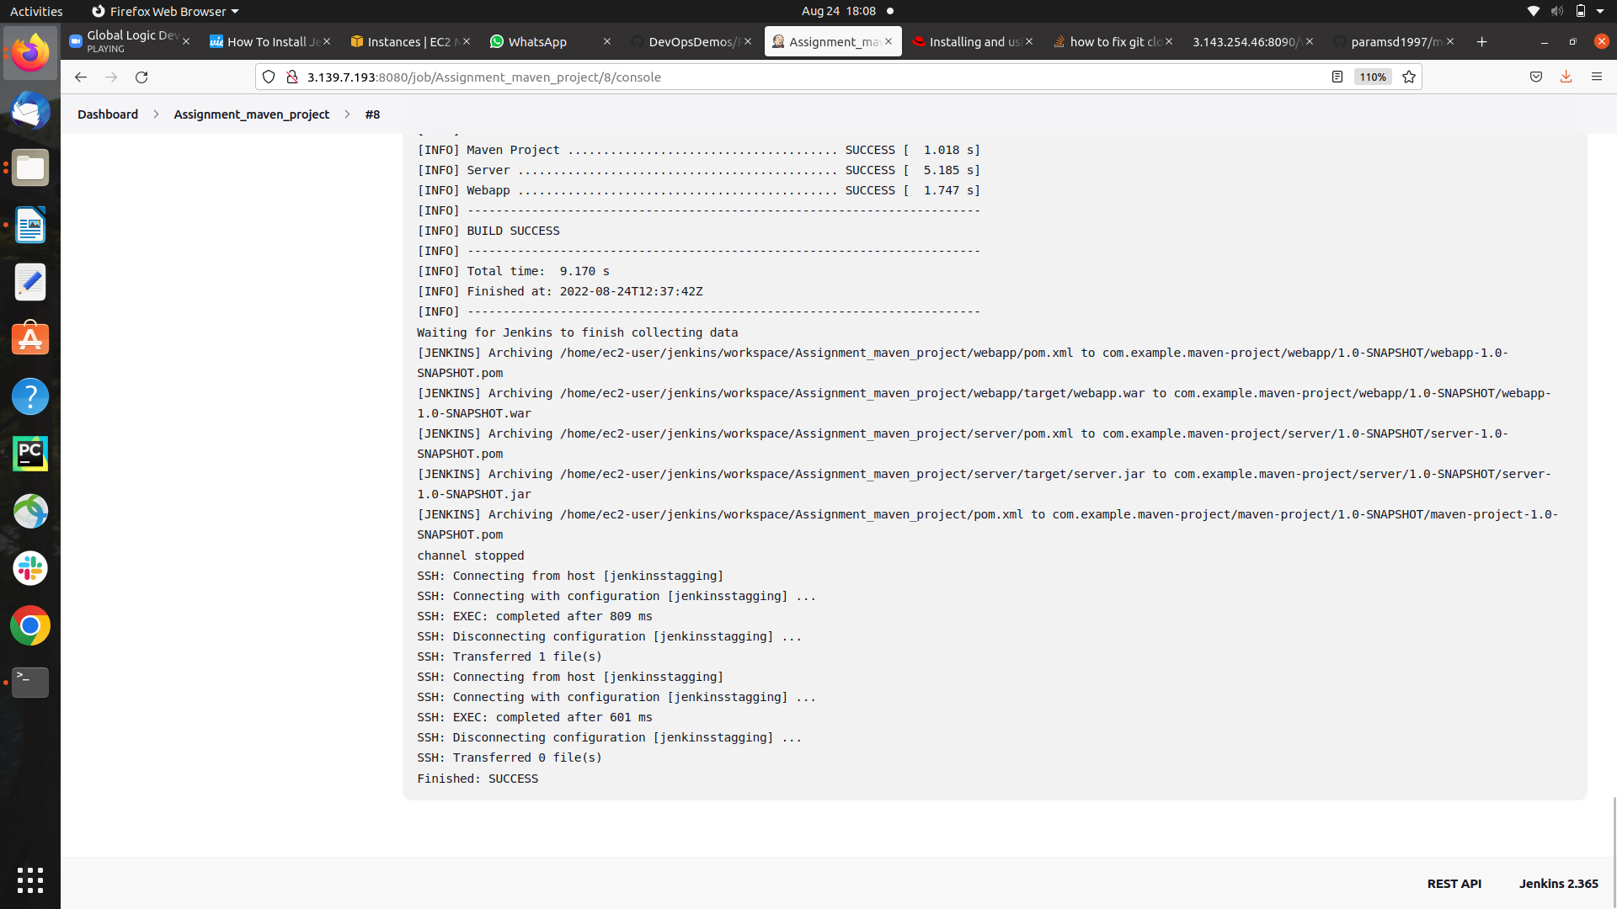

**step 5) Docker Container created Successfully**

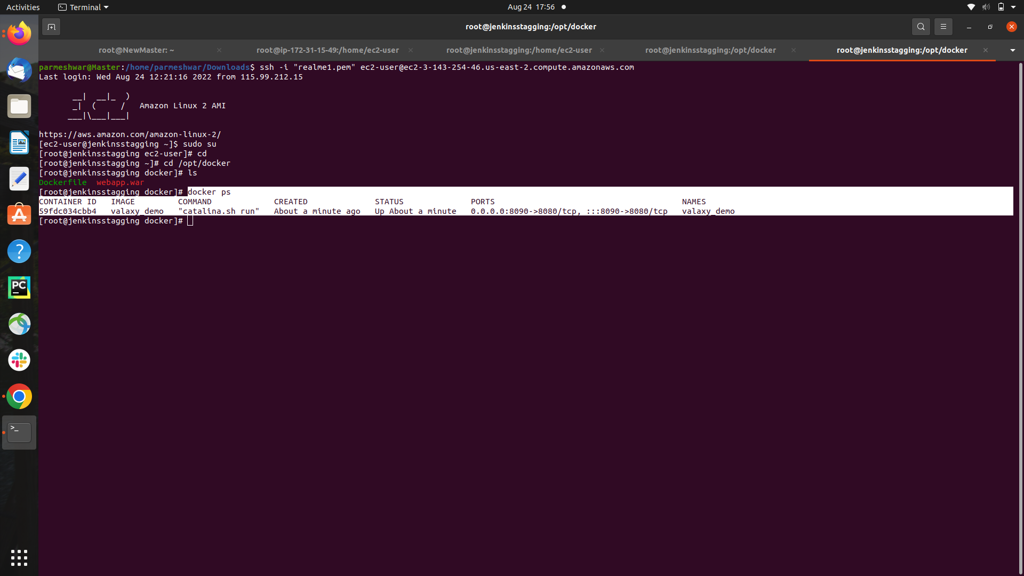

**step 5) Docker images of Tomcat created Successfully**

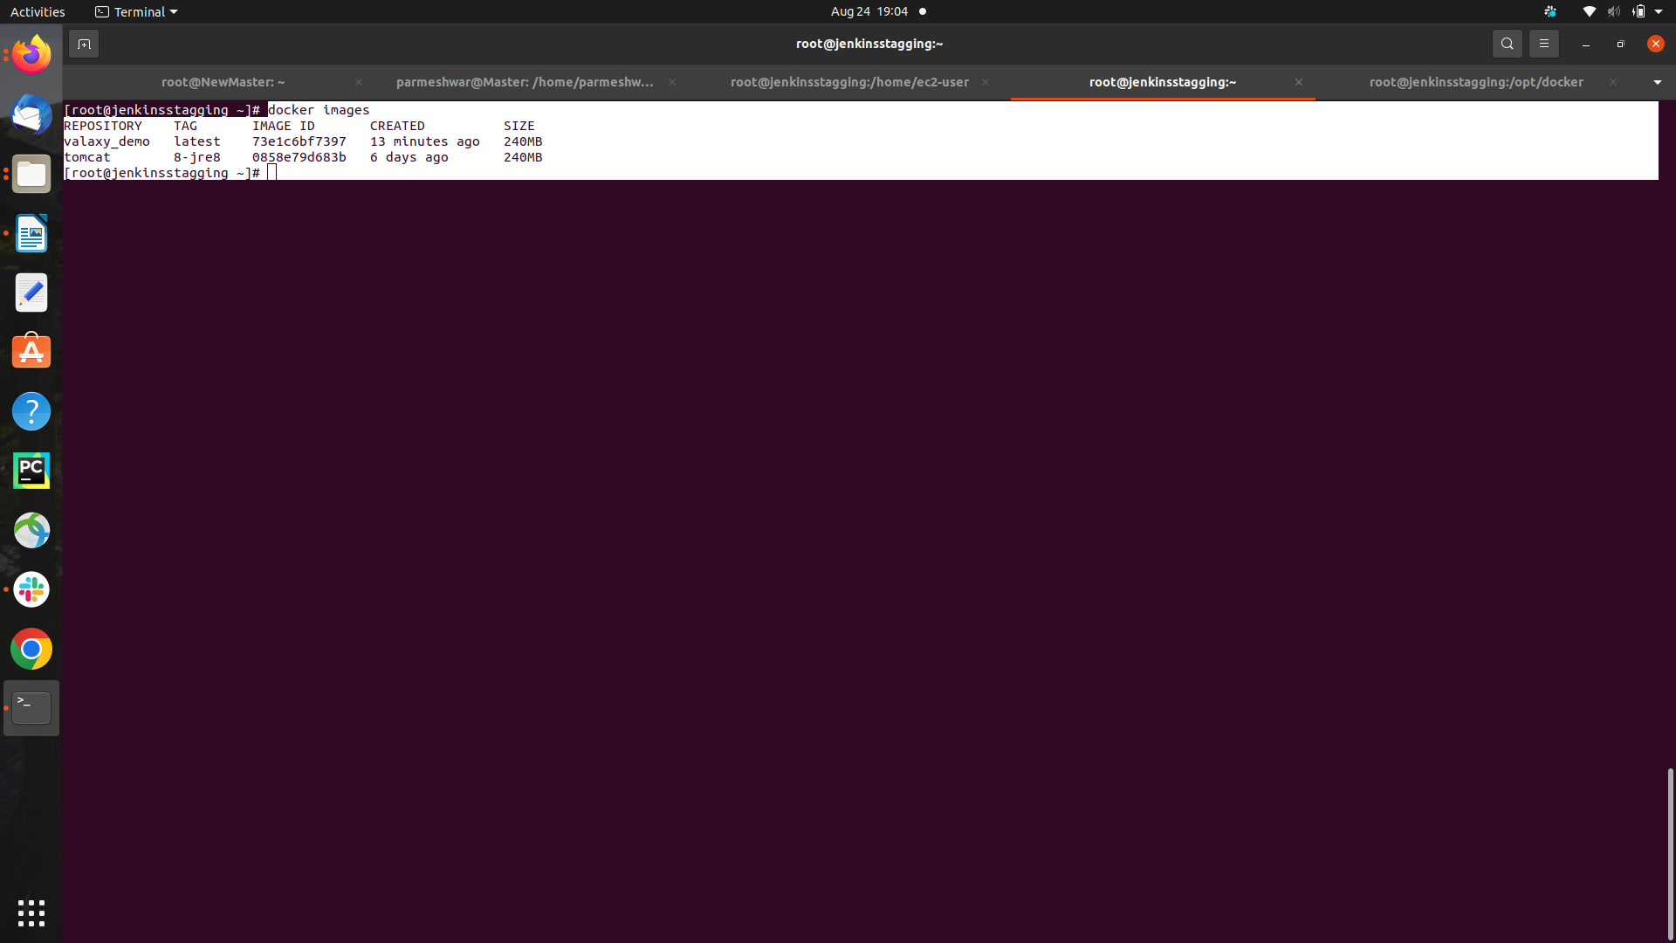

**step 6) Accessing the default wegpage of tomcat using the Stagging m/c public ip and port no. Of tomcat 8080**



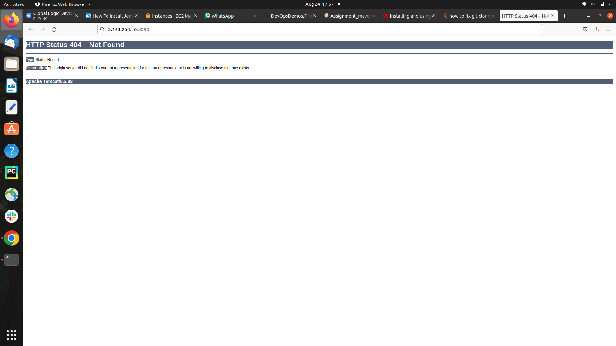

**step 7) Accessing the wegpage of using the Stagging m/c public ip and Assigned port no.**

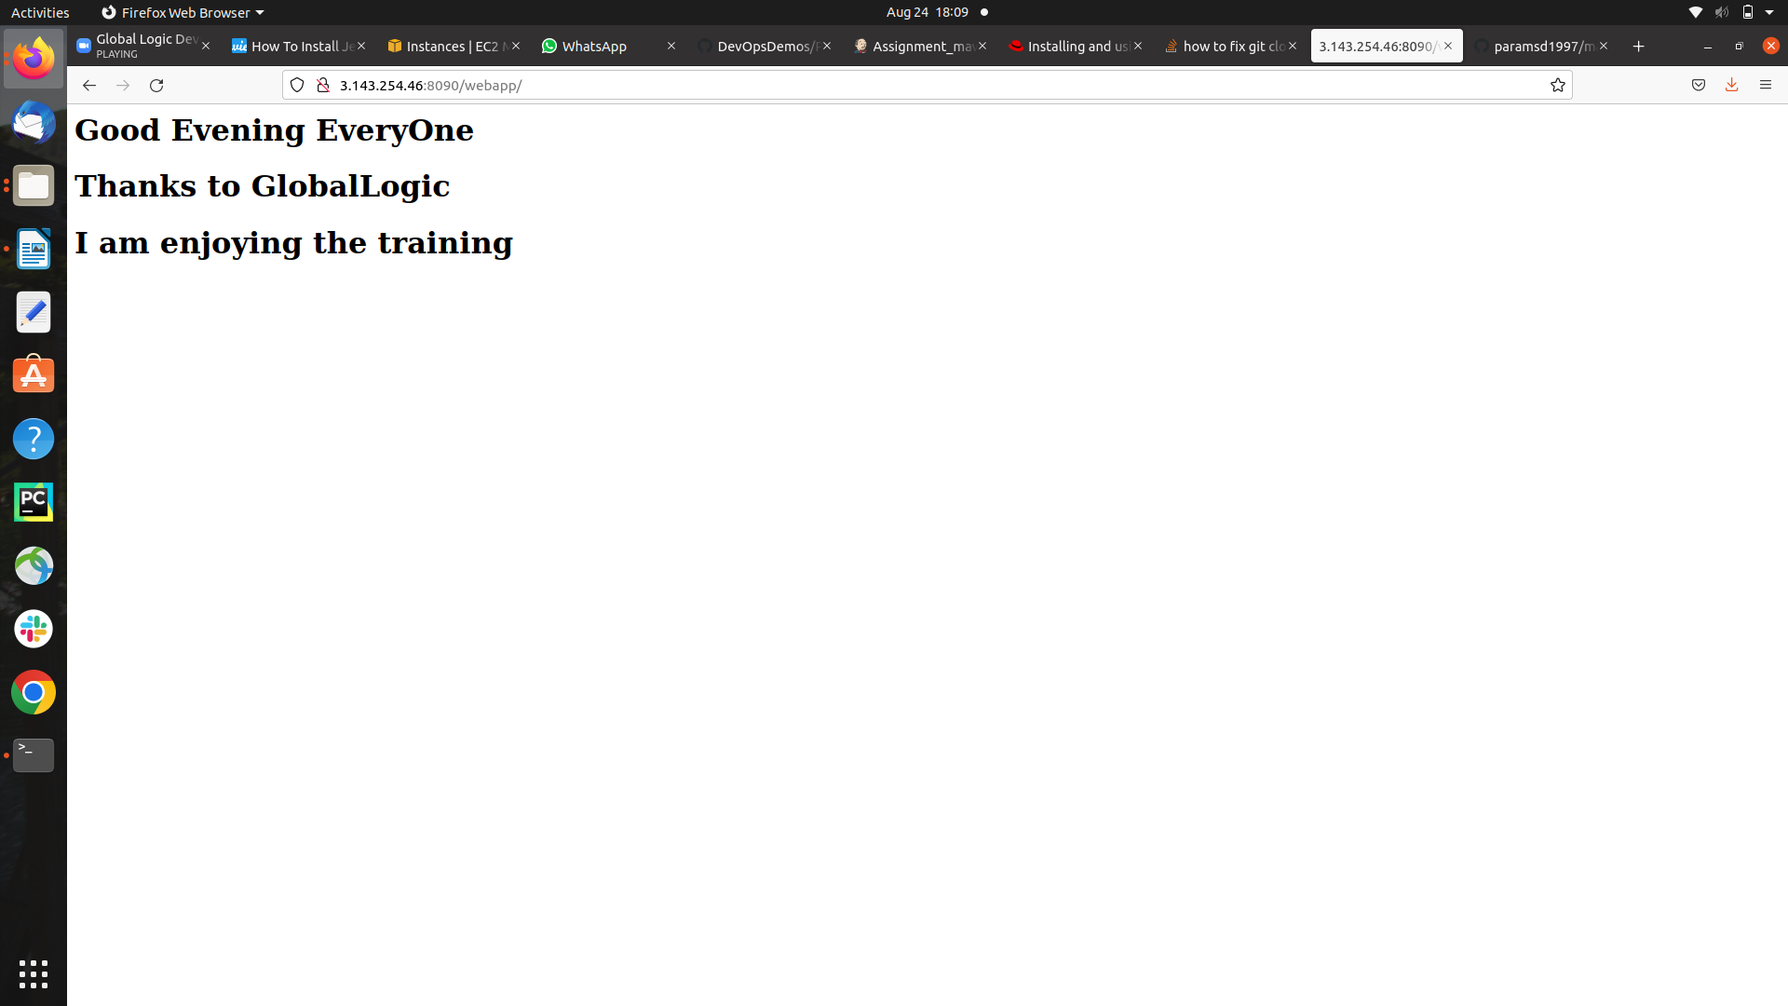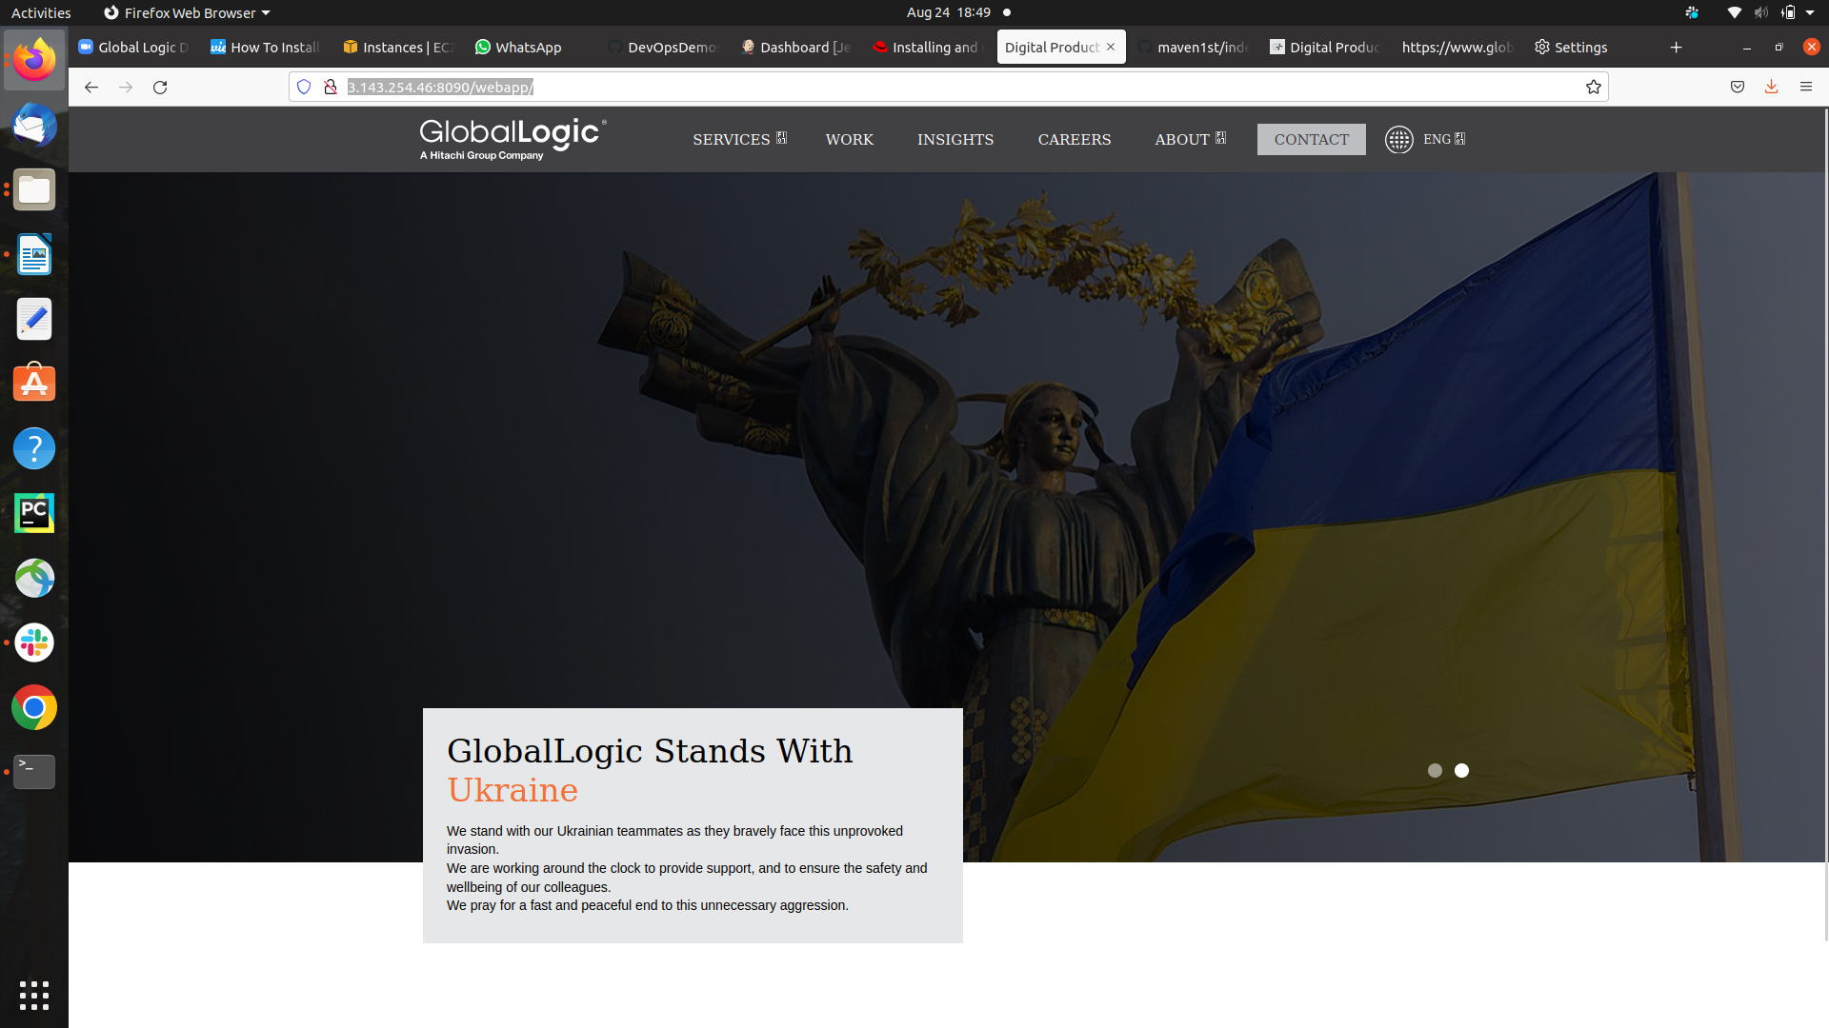**Changes did in the wepage that output Committed again**